### **SORA**

SORA is an AI-driven video generation platform that allows users to create dynamic and high-quality videos through text prompts or minimal input. Powered by sophisticated machine learning models, SORA leverages advancements in neural networks and natural language processing to transform textual descriptions into fully rendered visual content. This tool can produce videos that range from simple animations to more complex, narrative-driven sequences, allowing users to specify aspects like character actions, backgrounds, and even moods. By removing the need for extensive video production skills, SORA opens up the world of video creation to a broader audience, including marketers, educators, and content creators.

### **Comparison with DALL·E and Alternatives like Pika Labs or RunwayML**

SORA, while similar in concept to other AI-based creation tools like **DALL·E**, **Pika Labs**, and **RunwayML**, is primarily focused on video generation. **DALL·E**, created by OpenAI, specializes in image generation from text prompts. DALL·E’s strength lies in producing visually striking images, but it doesn’t natively extend into video creation. In contrast, SORA brings the concept of AI-driven generation into the realm of moving images, offering users the ability to generate fully animated sequences.

On the other hand, **Pika Labs** and **RunwayML** both offer video generation capabilities as well. **RunwayML** provides a robust suite of tools for creators to work with AI in various media formats, including video. Its platform supports real-time collaboration, with features like video editing, generative art, and more, making it versatile for both experienced professionals and beginners. **Pika Labs** takes a similar approach, focusing on simplicity and accessibility, allowing creators to generate videos easily, though it may not be as feature-rich as RunwayML.

What sets SORA apart is its specific emphasis on enabling creators to input text descriptions and receive videos in response, streamlining the process of video content creation. However, while SORA excels at simplifying the production of videos, it may not yet match the customization options or advanced editing capabilities offered by tools like **RunwayML**.

### **Ethical Considerations in Video Generation**

The rise of AI tools like SORA and others presents significant ethical considerations. **Deepfakes**, which involve synthetic video creation, have raised alarms about misinformation, privacy violations, and the potential for harm. AI-generated content can be used to create deceptive or harmful material that may mislead audiences, damage reputations, or infringe upon personal privacy. For instance, generating fake news footage or manipulating individuals' likenesses in videos without consent could lead to dangerous societal consequences.

Moreover, the democratization of video creation through AI technologies raises questions about **authorship and ownership**. With AI tools generating content from minimal human input, the line between creator and machine becomes blurred. Who owns the rights to videos generated Finally, there is the concern of **job displacement**. As AI-generated videos become more prevalent, professional video editors, animators, and content creators may face competition from these automated systems. While this technology can be a powerful tool for enhancing productivity, it also disrupts traditional employment in the creative industries.

Ethical AI use in video generation, therefore, requires transparency, clear policies, and a balanced approach to foster innovation while mitigating potential harms.

**PROMPTS**

**1.AI-Enhanced Learning Adventures** *"Design a digital learning experience where students embark on historical or scientific quests with AI guides. For example, they could travel through Ancient Egypt or journey into a human cell, interacting with the environment, solving problems, and learning as they go. What features would the platform offer to engage different types of learners?*

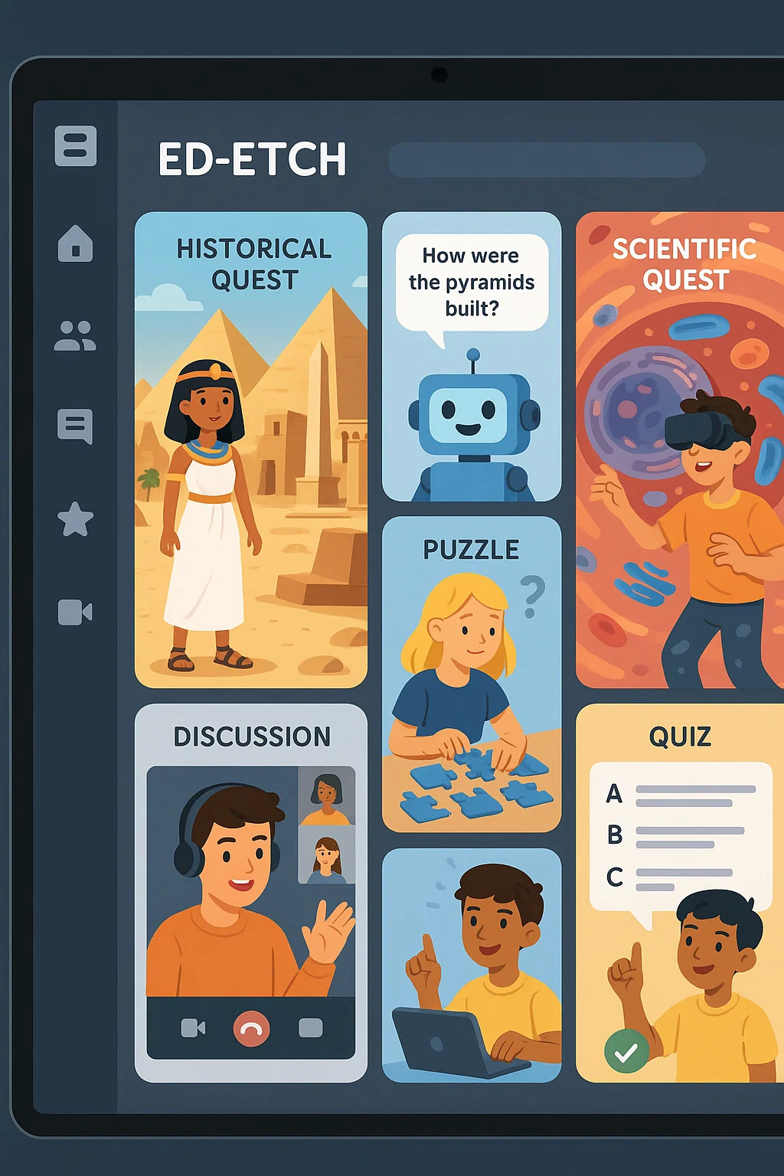

**2.Virtual Reality Concerts**

In the year 2040, concerts are mostly experienced through virtual reality. Design a VR music experience for a famous band—what elements would you include to make it truly immersive?

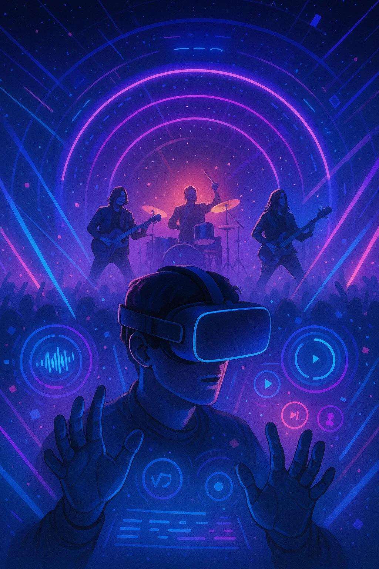

**3. Climate Change Utopia**

Imagine a world where humanity has successfully reversed the effects of climate change. How does the environment look? What new technologies or societal changes allowed this recovery?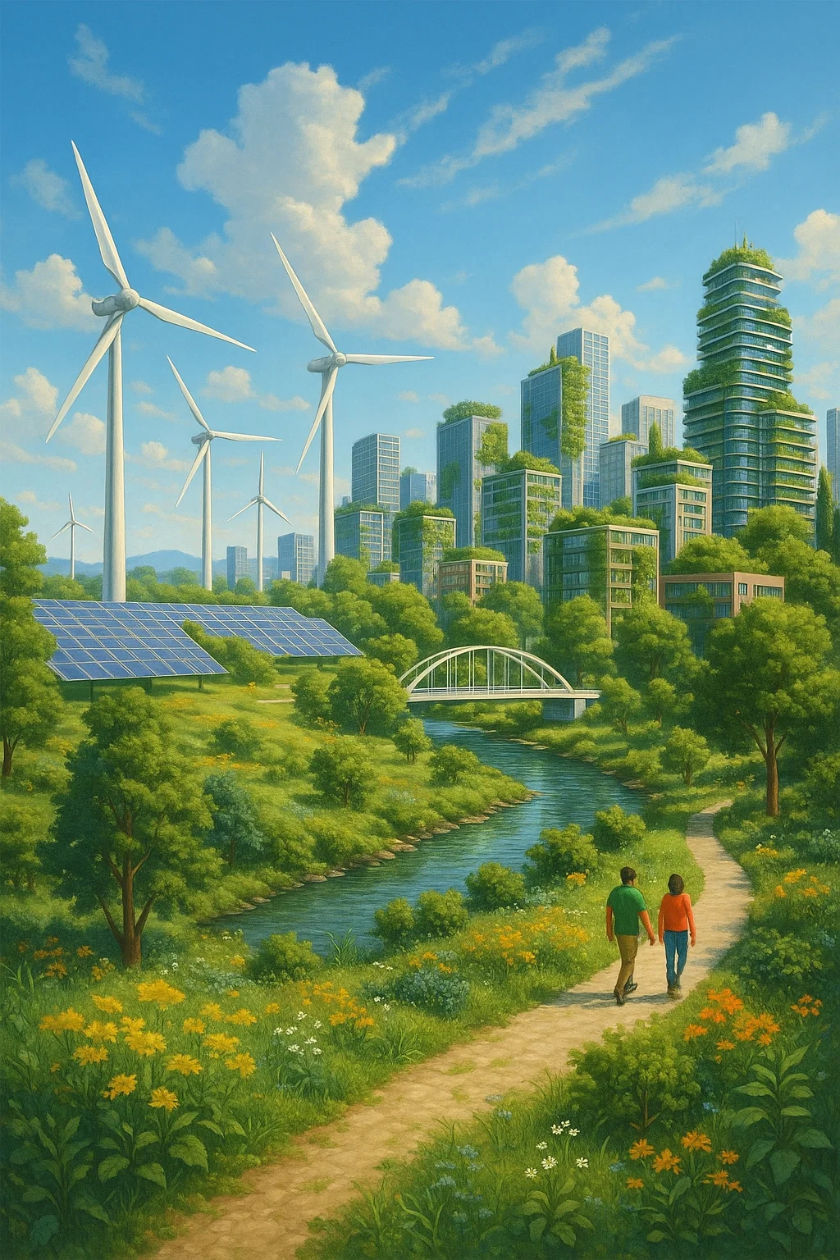

**4.Life with Brain-Computer Interfaces**

In a world where every person has a brain-computer interface, describe a day in the life of someone using the technology to enhance their cognitive abilities. What are the social, psychological, and ethical effects?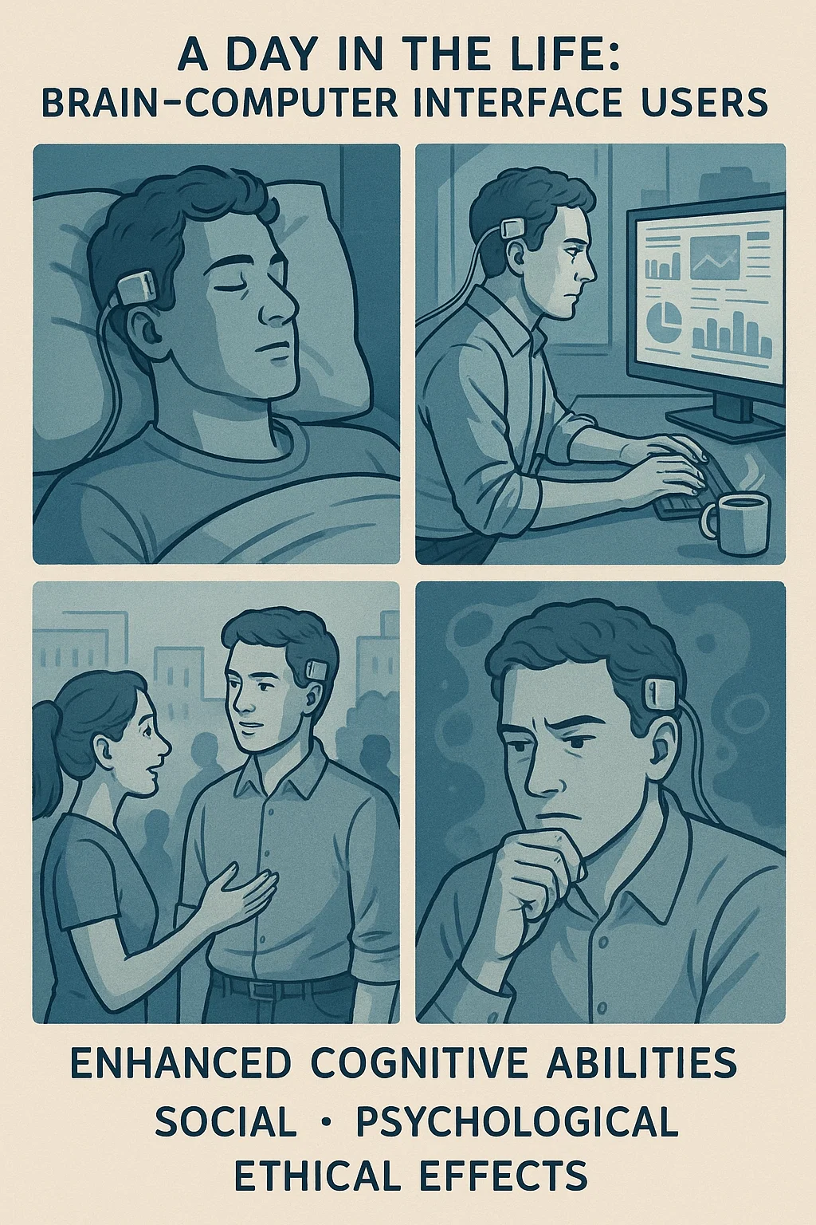

**5.Mental Health Tech**

Design a new kind of mobile app or wearable device that helps users maintain mental wellness. How does it work, and what innovative features make it stand out from current offerings? 